5-jan-2017
LibertyBSD installation/configuration guide
By Maarten van Druten & Michael Reim Version: 0.2.3
Goal:
Installing Liberty BSD on the computer with Lumina® packages and
standard applications.

LibertyBSD is based on OpenBSD, therefore this manual could also be useful for people that want to install or configure OpenBSD.
Because LibertyBSD is based on OpenBSD, you should look at OpenBSD's security announcements.
https://www.openbsd.org/errata59.html
The difference is that LibertyBSD has been "deblobbed" and therefore doesn't contain any not free software packages.
the official package repository is:
http://libertybsd.net/pub/LibertyBSD/5.9/packages/

Installing LibertyBSD
You can download a bootable CD image of LibertyBSD at this website:
http://libertybsd.net/
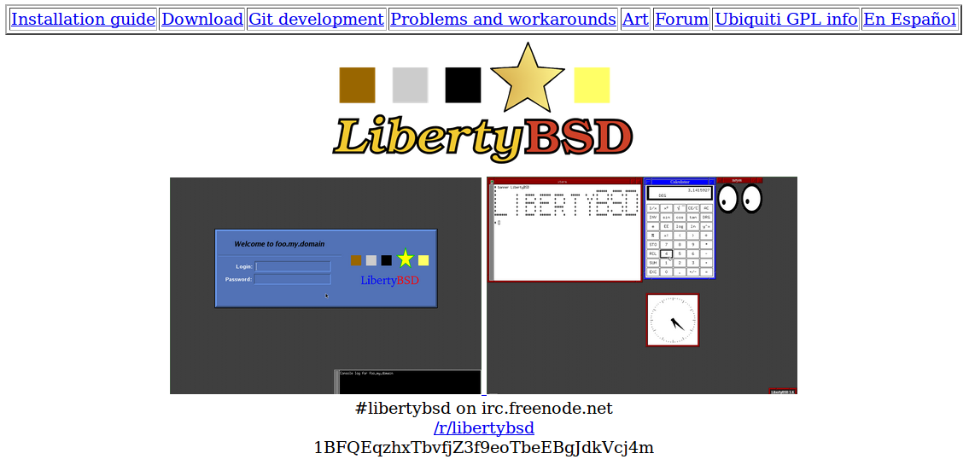
Go to the downloads section:
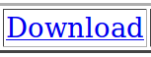
Click on it, then you will see this text:

Click on “Download LibertyBSD 5.9 here”
Then you will see this page:
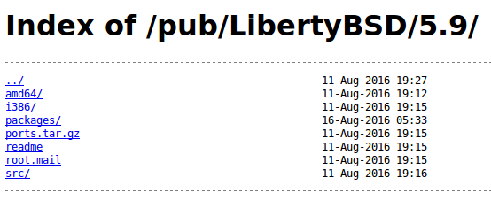

Select the right folder that correspond with the CPU architecture of your PC
For example:

For Intel 64bit CPU's select: amd64
For older 32bit CPU's select: i386
In this example I will install LibertyBSD on a Intel Core i5 processor, so I choose: amd64

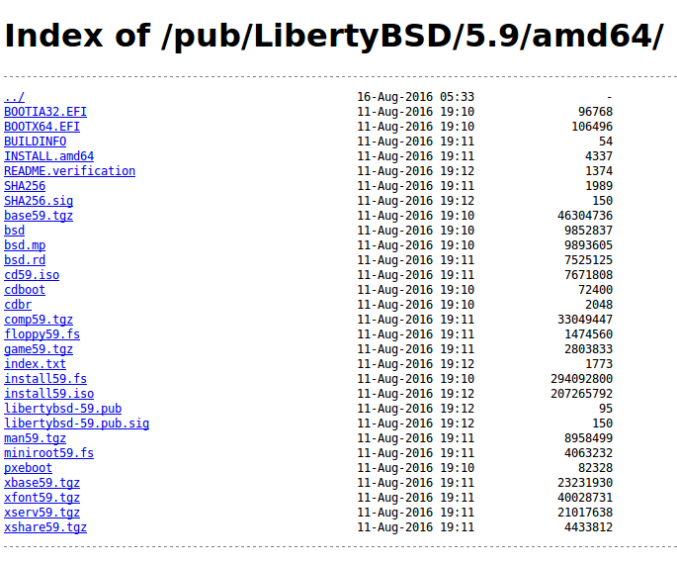
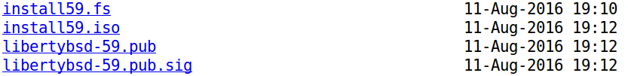

Select from the list the install59.iso file
and download this file to your computer. (for example to the Downloads folder)

Important!
To make sure that the file is not tempered with, you should always verify your download! And check if the file is not corrupt and that it's original.
You can easily do this by downloading the checksum SHA256 file, that also located in this directory.

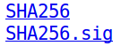

Download the SHA256 and SHA256.sig file to your computer.
(for example to the Downloads folder)

Then start a terminal on your computer, and go to the folder were you downloaded
the install59.so, SHA256 and SHA256.sig files
In this example: cd Downloads

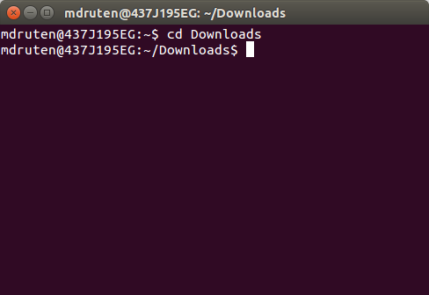

Then type: sha256sum install59.iso

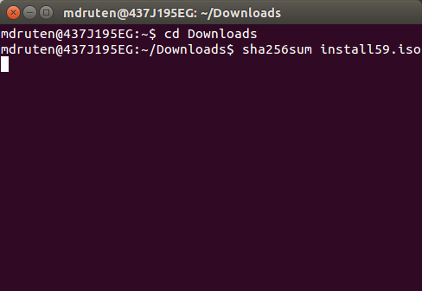

The answer is:
1244e15ca35ee967f7f44da8bbe0240ce086c3287ecc81f3df26e80c2d3a966d
This long line is called a hash (it's a alphanumeric string)

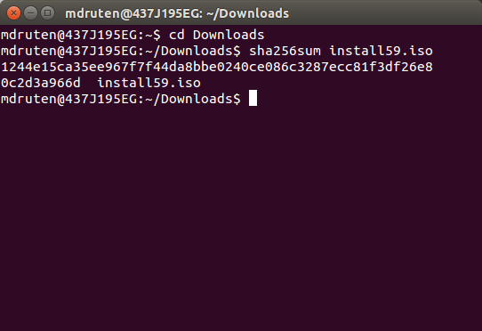

Then we have compare this hash, if it's the same then printed in the file:
SHA256
To do this go to your file manager:
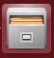
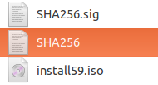
Open the “SHA256” file with “gedit” (by double clicking it)
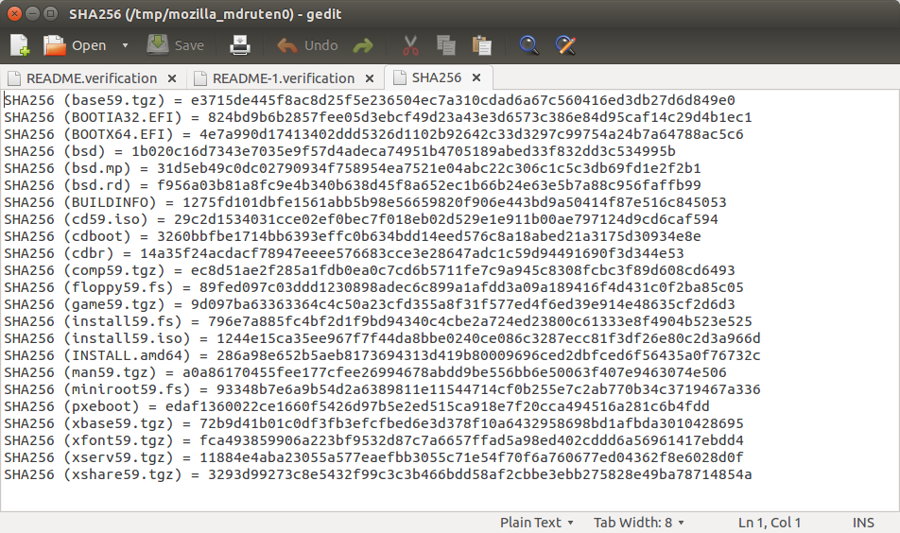
Locate the hash of the “install59.iso”

The hash in the text is:
1244e15ca35ee967f7f44da8bbe0240ce086c3287ecc81f3df26e80c2d3a966d
The hash from the terminal after typing sha256sum install59.iso was:
1244e15ca35ee967f7f44da8bbe0240ce086c3287ecc81f3df26e80c2d3a966d

These two hashes are identical, and this is good, so now we know that the iso
is correctly download, not corrupt and has not been tempered with.
No we can proceed with the installation steps

Burn the “install59.iso” on a CD

Put an empty CD-R in your CDROM writer of your computer
Start your cdwriter software
For example “K3B”



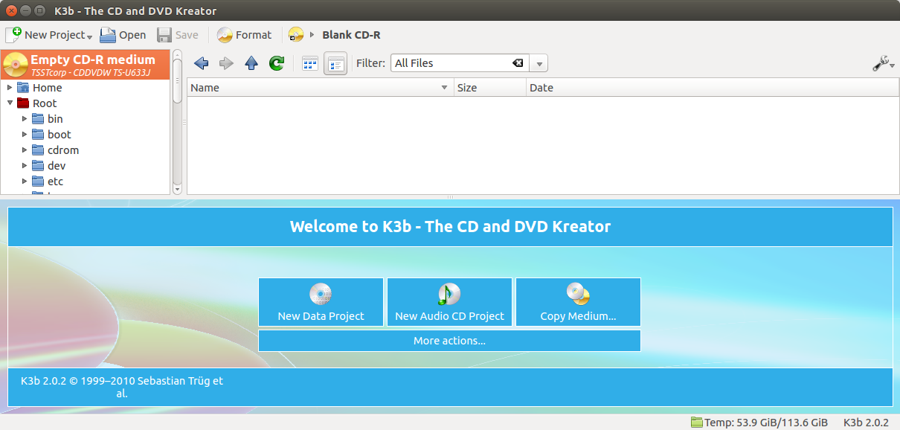
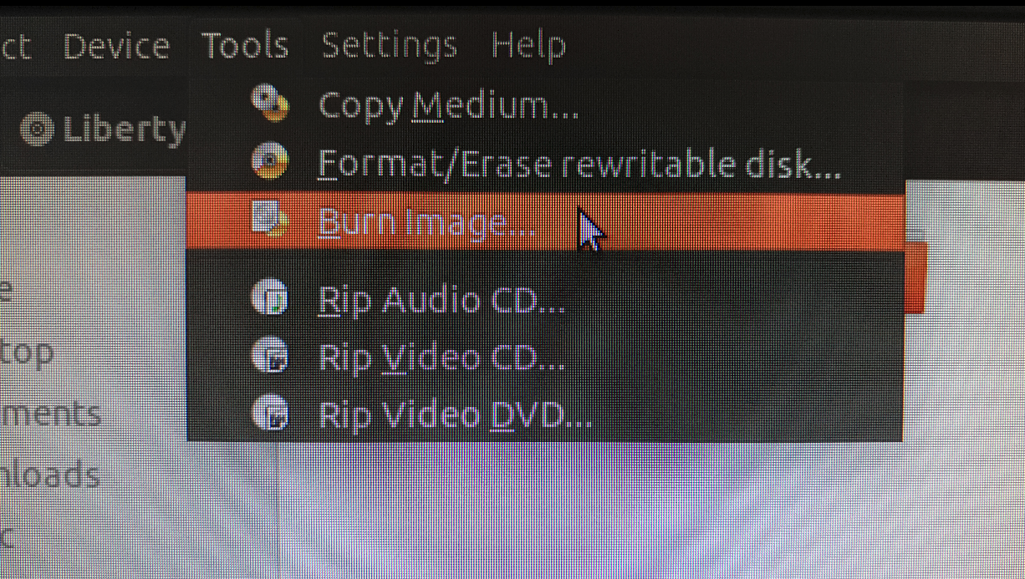

Go to “Tools” - “Burn image...”

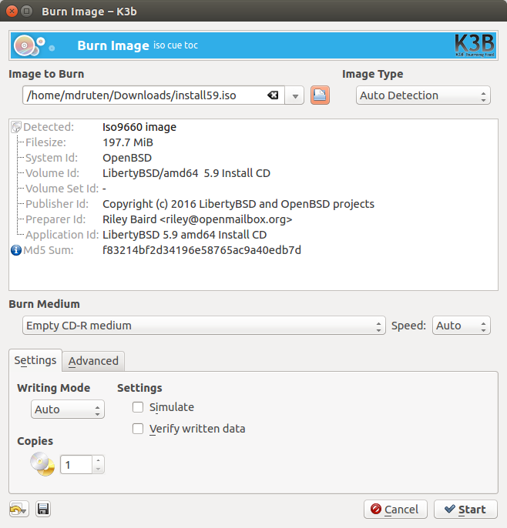
You will see this screen
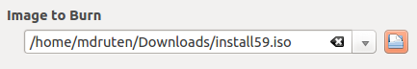
Click here to select the location and the file which you want to burn to CD

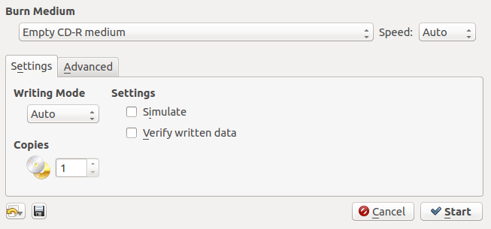

Then click “Start” to burn the iso image to CD

After burning the “install59.iso” to CD, place the CD in the CDROM player of the computer were you want install LibertyBSD on.

Important:
All data will be erased of your computer by following the instructions of this manual, so if you want to make a backup do it now!

After placing the CD in your CDROM player and turn on your computer,
Wait for the installation program to show up.

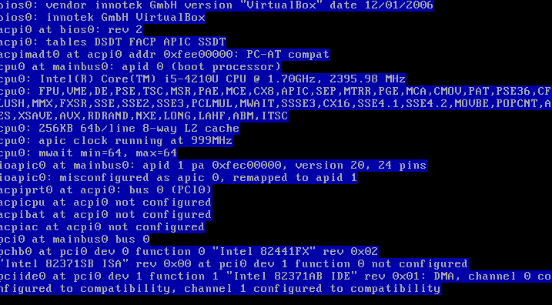
First you will see text like this, and after some time, at the bottom you will see this text:

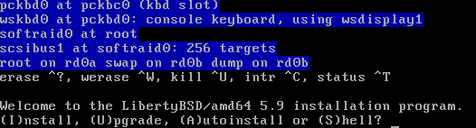

There you have the choice between (I)nstalling, (U)pgrading an existing installation, doing an (A)utoinstall or going to a (S)hell. Choose "i" for now.
And press “enter”

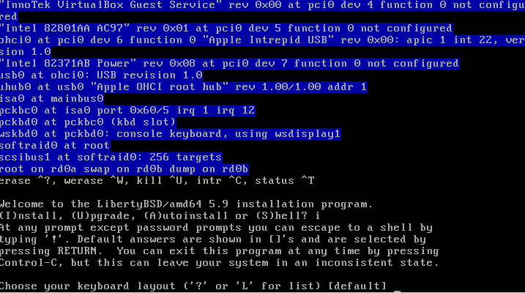
Now choose your keyboard layout. If you don't know how your layout is abbreviated, type "L" + “enter” and have a look at the list.
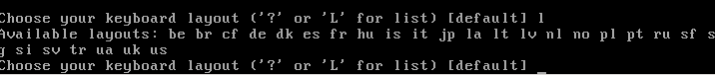
Just press “enter” to select the default keyboard
Next is the host name.
But you want a secure system, right?
So think about this for a moment. If you have your own domain you likely know what hostname you want to use. If you don't know what this is all about, just think giving your machine a name inside your network. DO MIND that it is part of a network even if you have just a single machine at home and you don't own a domain! It's still good practice to make up a domain name - just don't use a valid one that somebody else may own or buy in the future! The typical way of avoiding this is leaving out the "top level domain" (i.e. the "domain ending" like ".com", ".net", etc.).
"libertybsd.local" e.g. is generally fine as a hostname for a test machine. Be aware though that your hostname is public and for that reason may give a possible attacker hints on what system you are using. You may prefer to use a more generic name like "pc-01.local" and stay away from using names than contain "libertybsd", "puffy" or anything else that suggests you're using an OpenBSD based system. The internet is a warzone and leaving your potential enemies in the dark is a little security plus. But whatever you do: Stick to lowercase letters, numbers and dashes. DON'T use uppercase or weird characters! If you ignore this rule, you can get all sorts of strange problems later.
In this example I will use a non-personal (anonymous) computername:
- that doesn't reveal the type of operating system, or manufacturer of the computer
- that doesn't give any personal information about the user
The computername in this example will be: 692k22s
(type you own computername, not this one! and press “enter”)
When you gave the installer the host name it will ask you to configure your network interface cards (NICs).
Have a look at what it offers as available NICs. Linux used names like "eth0", "eth1" and so on in the past and uses strange generic names like "enp0s2" today.
BSD names interfaces after the driver that is used to communicate with them. So if you e.g. see an "em0" NIC, you know that it is the first device that uses the "em" driver. If you want to learn something about its capabilities later, you can "man em".
Choose the right NIC and confirm by pressing “enter”.
The next step is choosing how the NIC gets its address. You can either enter a static IP if you want (or have to) or go with the default of using DHCP which will auto-assign an address if there's a DHCP server on your net. Choosing DHCP when it's available is the easiest setting as you don't have to care for the default gateway, DNS server, etc. Otherwise you must provide that information yourself.
DHCP is selected as default, so if you want DHCP press “enter”.
After some seconds you will see the following screen: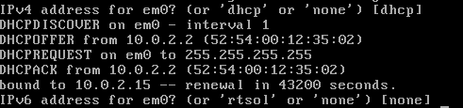
After configuring your NIC for IPv4, the installer lets you choose whether you want to use IPv6, too.
If you want to, configure it now (RTSOL is the IPv6 equivalent for DHCP). Tip: If you don't know if you have or want IPv6 then it's pretty safe to assume that you don't.
Choose "none" in this case.
“None” is default selected, so press “enter”
With the first NIC configured, the installer will give you the chance to configure more NICs if you have any (and want to use them, too). If you do, select which one to configure next and repeat the previous steps for those as well. If you don't want to configure any further NICs opt for "done".
“done” is default selected, just press “enter”
But this can take a very long time... (10 minutes or more)
After some time you will see these lines...
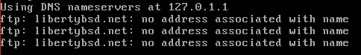
Setting the root password is the next step.
This is not Ubuntu and the installer expects you to know that "abc" is a very bad password. It won't tell you, though and if you really want to use a bad password that's your problem. It won't stand in your way. So use common sense here.
Choose a sufficiently long and complex password for the root account.

Note:
How to create a good, secure password:
Good passwords are long, very long
Therefore always use a passwords that's consists out of mutiple random words like:
“correct horse battery staple” or:
“green coffee vacation fish”
and then add some caps, numbers, and special symbols to it, so you password
will look like this:
“Correct4HORSE@Battery5000Staple!” or “GREEN6712coffee@vacation2FISH?”
This are examples of better and more secure passwords, so always remember the longer, is better!
And never use a “password manager” for your passwords! These programs are not safe.
If you cannot remember your password, just buy a small addressbook that can fit in your jacket pocket.
And keep this small addressbook always with you!
Never store passwords in telephone apps, on a computer in digital form, or passwords managers.

type the long secure password, en press “enter”
type the long secure password again, en press “enter”

The answer to the next question depends on what kind of system you're setting up. For a server you usually want SSH enabled, for your desktop you probably don't. If you are not familiar with OpenSSH, just think "remote access". Don't want to remotely access your machine? Then answer "no".
This manual describes how to configure LibertyBSD as a normal desktop computer for daily use, so we are not going to use “SSH”
Type “no” and press “enter”
After that you'll be asked if you expect to run the X Window System (also known as "X11" or in case of OpenBSD's hardened version thereof, as "Xenocara"). Since you're setting up a desktop system you definitely want to answer "yes" here!
(“yes” is default selected – so press “enter”)

Now the installer wants to know if X11 should be started by xdm. This basically means: "Do you want a simple graphical login?". The alternative is logging in in textmode and then starting X11 by hand if you need it. It might be tempting to answer "yes" here for desktop usage. Resist doing so, however, and answer "no".
We'll install a better graphical login program (usually called "display managers") later. XDM works but it's not pretty and has a few other downsides.
(“no” is default selected – so press “enter”)

You have the chance to setup a user next so you aren't left with just a root user on your new system. For server setups this is an excellent idea since you can then restrict SSH so that remote root logins are not allowed. For the desktop I suggest to skip this now and create your user later (leaving you more freedom when choosing your shell, etc.). So answer "no" here as well.

The installer will ask which disk you want to use as the root disk. IDE drives are named "wd" starting with "wd0" and SATA devices go by the name of "sd". Choose your root drive now.
"wd0" us default selected, press “enter”
Now you are asked which which partitioning scheme you want to use. MBR is the old one allowing for up to four primary partitions (and some "extended" ones). GPT is newer and much more flexible. However GPT support in OpenBSD is rather new and primarily there to support installations on EFI based machines (which are not currently covered in this installation manual). You also have the possibility to customize an MBR setup through manually editing. I strongly recommend pressing "W" and dedicating the whole drive to LibreBSD. Multi boot environments are an advanced topic that is not particularly easy to do right if you're a newcomer.
“whole” is default selected, press “enter”
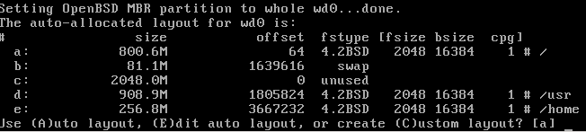
Next you'll be asked about the disk layout. The installer suggests a layout going from "a" to "k" - which really is a mouthful, especially if you're new to the system! The first thing that you need to know is that in the traditional BSD world (MBR) partitions are divided further into what you would probably want to think of as "sub partitions" (the mechanism referred to as "disklabels").

Why are there so many partitions? Two of them are actually "convenience partitions" (/usr/src, /usr/obj). From a developer perspective you're often going to recompile the system and in such a case you pretty often want to start over with a clean source. To do so you must first delete the old one. As the system source consists of a huge number of files, deleting them all is slow. Simply re-formatting the partition is much, much quicker! This means: If you're not a developer, you may not need these partitions. But as long as your drive is big enough, they also won't hurt you, either.
Then there's partition "c" which is special. It always exists (even if there are no other partitions in your disklabel) and you cannot use it as a normal partition. It refers to the whole disklabel - from the first to the last sector. It's a bit strange that it's "c" but that's for historical reasons and we cannot do anything about it.
But even without "c" and the two convenience partition, that's still a lot of them! That's because OpenBSD uses them as a security feature. In the world of Unix-like systems partitions can be mounted with various options set. Such options can prevent binaries from being executed ("noexec") or forbit suid (running programs with elevated permissions for non-root users) among others. Using multiple partitions instead of just one or two allows OpenBSD to apply a more fine-grained mount options scheme allowing for better protection of your system
If your drive is big enough (say 20 GB and more) you'll best leave the default layout alone and just use the suggested auto layout by choosing "a".
“a” is default selected, press “enter”

At this point the installer is going to ask you for the location of the distribution sets and tell you the options that you have. "cd0" should be fine.
“cd0” is default selected, press “enter”
“5.9/amd64” is default selected, press “enter”
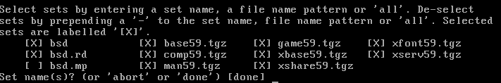
You'll be presented with a simple dialog to select which sets you want to install. If you don't know what "sets" are think parts of a modular system.
"bsd" for example is the kernel - it is required.
"base" is the base system which consists of the basic system utilities and configuration files.
"comp" contains the compiler,
"man" the manpages and
"game" a few simple games.
The "x" packages contain Xenocara.
If you don't have a really small disk you should probably just install all the sets. In case the installer does not automatically select "bsd.mp" don't worry: That's a kernel optimized for machines with multiple cores which is not needed on single core systems (but won't hurt you, either).
Type in the name of the set (e.g. "man59.tgz") to select it. Prefix it with a minus (e.g. "-game59.tgz") to deselect a set. You can also use the "*" wildcard; "-x*" deselects all Xenocara sets while simply "*" selects everything.
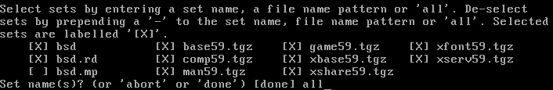
Type “all” and press “enter” to install all sets.
“Done” is default selected, press “enter” again.
The installer will then tell you that it cannot find the checksum signature. Unless you use officially bought OpenBSD CDs this cannot be avoided. So you'll have to type "yes" here.
“no” is default selected, type “yes” and press “enter”
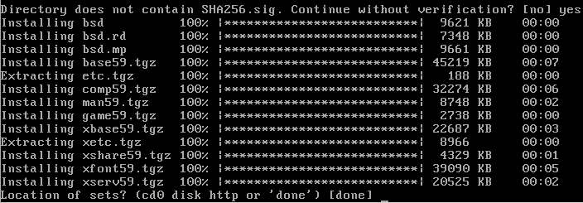
Now the actual installation begins by extracting the distribution sets. When that's done, you could install more sets from a different location. However we installed everything that we need and thus choose "done".
“done” is default selected, press “enter”
The last question that the installer asks is the timezone that you're in. Choose your timezone here (use "?" if you need a list).
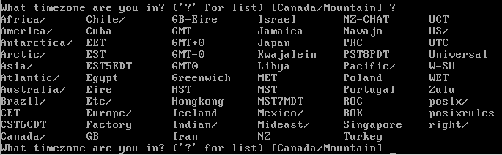
Type your timezone abbreviation and press “enter”
For example: “CET” (Central European Time)
type “CET” and press “enter”
After setting the timezone the installer configures the system, creates device nodes and quits.
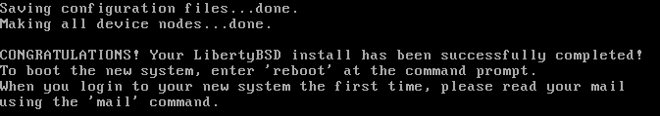
At this point you should remove the boot medium and type "reboot" to boot into your new system!
type “reboot” and press “enter”
The installer recommended reading the system mail if you're new to the system and this is not a bad idea if you already have some knowledge about Unix-like systems. If you don't have that a lot of the topics may be over your head, though, and you probably want to follow this manual to get to a graphical desktop system first before you start playing around with the OpenBSD specific things.

Configuring LibertyBSD

After intalling LibertyBSD, now we are going to configure it, start the computer:
LibertyBSD is booting...
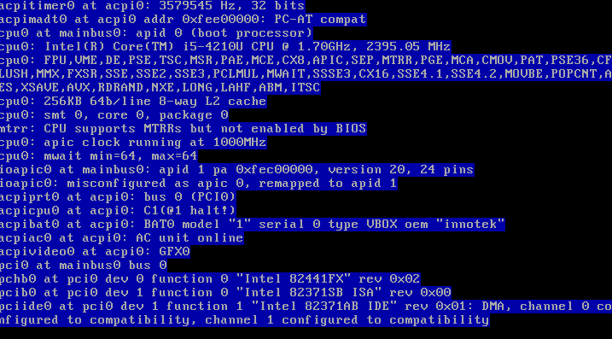

Then LibertyBSD show the login screen:

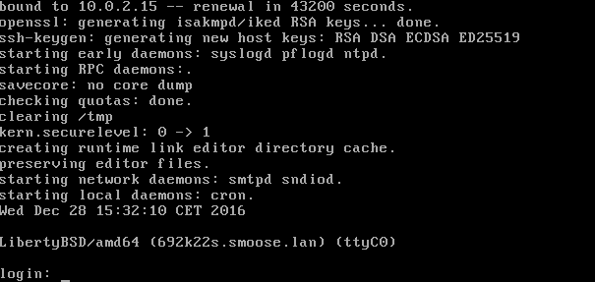

Login with the root user

type: “root” and press “enter”

and type your password and press “enter”

First we are going to make a regular user,
for this manual we use the name: “john”

Add your regular user to the “wheel” group

In termal type: user mod -G wheel john

